**TERMWORK 1**

Name : Sachin Alur

USN : 2GI20CS187

Output: (Message Queue)

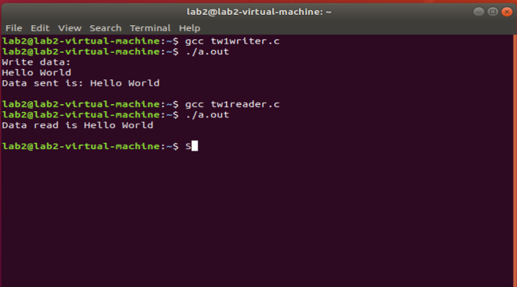

Output: (Pipes)

